Friday Night Jam
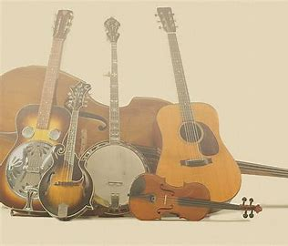
Join us for a good time!
Bring your instrument of choice, a comfy chair
& your voice!
Every Friday from 6pm to 9pm
At
Bethel UM Church Chewsville
21006 Twin Springs Dr.
Smithsburg, MD 21783
301-733-8387.

Musicians just hangin’ out and sharing their music!

