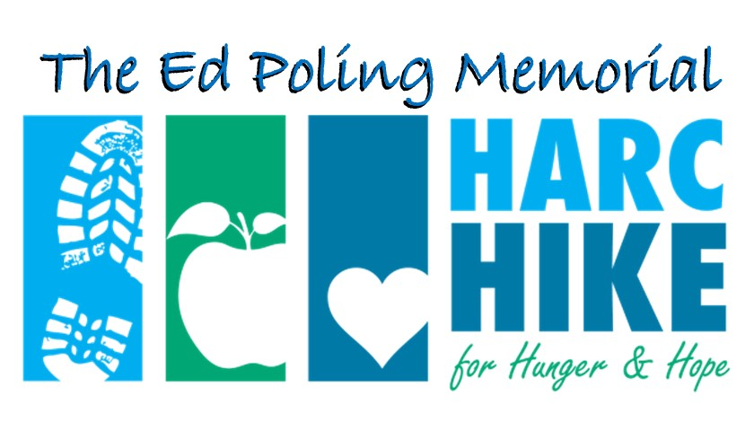
Sponsorship
opportunities

14th Annual HARC Hike
for Hunger & Hope
Saturday, May 30, 2026
www.harccoalition.org/hike

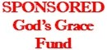
Friend $100
SPONSORSHIP LEVELS & BENEFITS: | Titanium  $2,000 | Lunch  $2,000 | Platinum  $1,000 | Gold  $500 | Silver  $250
Company logo on event t-shirt | At the top | At the top | √
Company name on event t-shirt |  |  |  | √ | √
Set up a promotional table and/or display your banner at event | √ | √ | √
Promotion on Social Media | √ | √ | √ | √
Logo on event emails & web page  with link to your website | Top  billing | Top  billing | √ | √ | name  only
Inclusion in press releases related to the event | Top billing | Top billing | √
Number of free event t-shirts  Number of free event entries | 4  of each | 4  of each | 3  of each | 2  of each | 1  of each

sponsorship
level includes listing on Hike web page


Sponsor Name as you’d like it to appear

Contact Name Phone

Mailing Address

Email Address Sponsorship Amount:

T-shirt size(s), if desired: Number participating in Hike:

Sponsors Gold and above: Please email your logo to director@harccoalition.org
Deadline is May 8, 2025 to be included on the event t-shirt.

Please make checks payable to: HARC ~ on the memo line of the check, indicate: “HARC Hike”
Mail to: HARC, P.O. Box 1158, Hagerstown, MD 21741-1158 ~ Thank you for your support!

