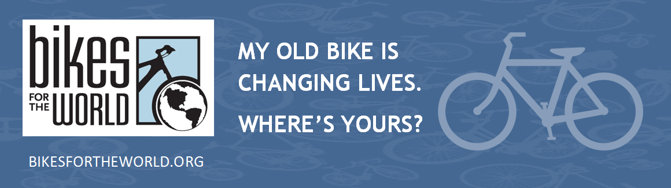
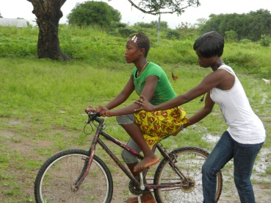
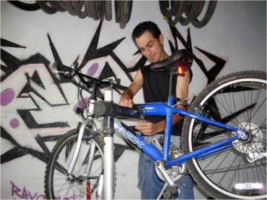
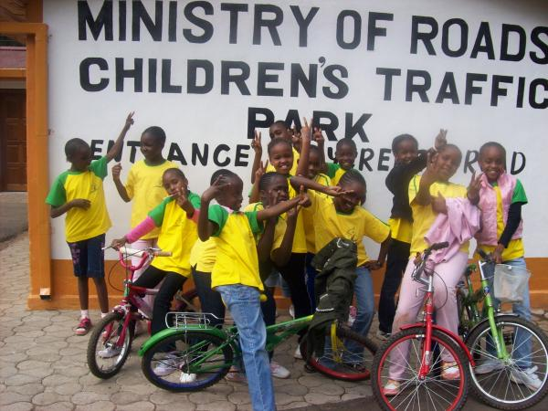
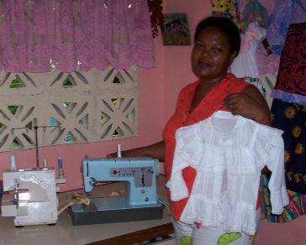

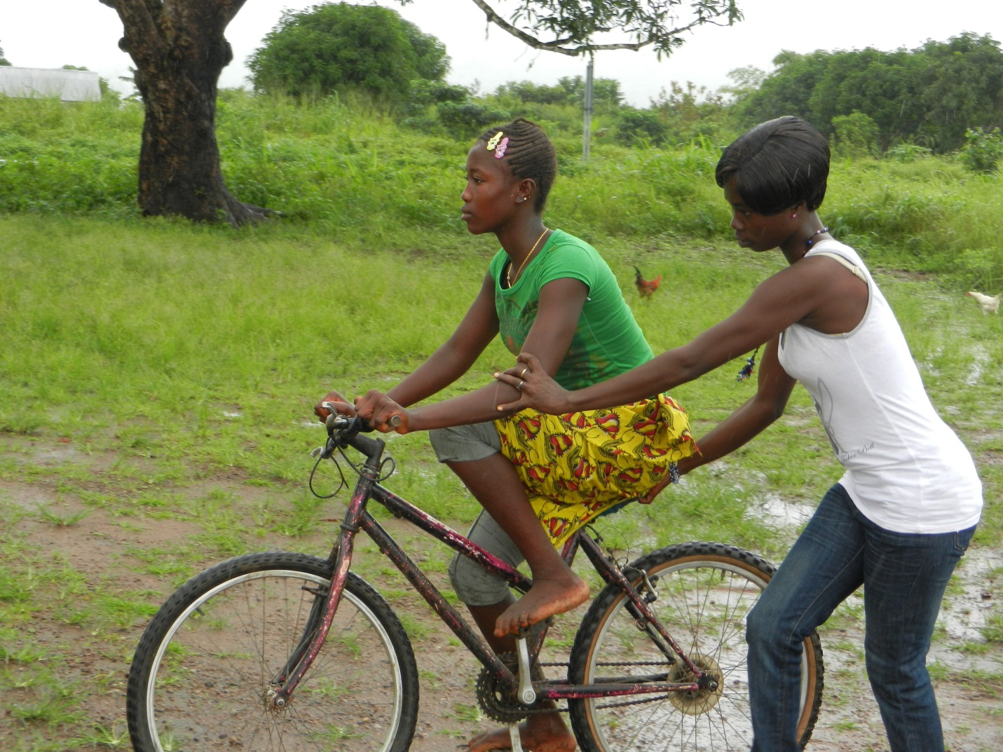
Saturday April 27 9am—12pm
20th Annual Collection!

Otterbein United Methodist Church
108 E Franklin St
Hagerstown MD 21740
301-739-9386

Contact info:
Cindy or Mike
cindybrownsr@gmail.com or mike@msjohnston.com
mike1@msjohnston.com or 301.331.9153

Re-Cycle
Re-Use
UPCOMING
BICYCLE COLLECTION
PUT YOUR OLD BIKE or SEWING MACHINE TO GOOD USE
Help someone get to work, school and health services.
DONATE IT HERE:
A $10 per bike donation is suggested to defray a share of the
cost of shipping to overseas charity partners, which recondition
the bicycles and distribute them to people who need them
to get to work, school, and health services.
Bikes for the World is a a 501(c)(3) non-profit charity. A receipt
will be provided for all material and cash donations. Checks accepted.
office@bikesfortheworld.org 703.740.7856

