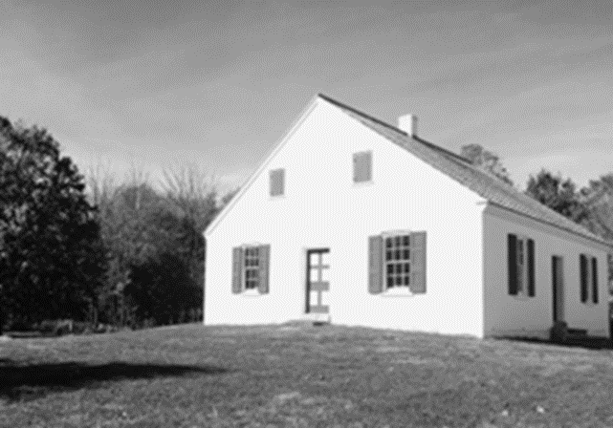
September 17, 2023, 3:00 PM
53rd Annual
Dunker Church Service

at the little white “Dunker Church” on the
Antietam National Battlefield, Sharpsburg, MD

Guest Speaker
Carol Scheppard
“Being the Church on a Battlefield“

Dr. Scheppard is on the faculty of Bridgewater College, Bridgewater, VA, in the Department of Philosophy and Religion. She also served as Moderator of the Church of the Brethren in 2016-2017.

The service this year is on the actual date of the Battle of Antietam, September 17, 161 years ago.

All are welcome to worship with us.

