Fish Fry

Saturday June 24th, 2023
Time: 11:00am until sold out.


$15.00 Donation
Includes: Delicious fried fish, Green beans, Mac & Cheese, Rolls, desserts, and drink.

where: Asbury UMC
155 North Jonathan Street, Hagerstown, MD 21740
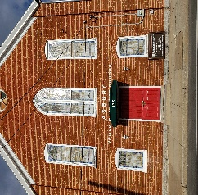
This Photo by Unknown Author is licensed under CC BY-SA

Pastor Sharon Gibson, 301-305-8166
Sponsored by Asbury’s Finance Committee

