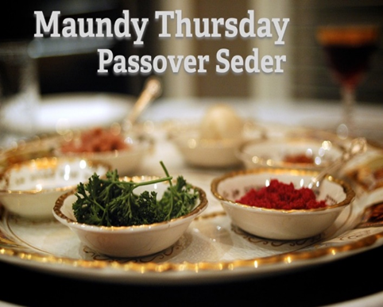

Join us maundy Thursday
April 6, 2023 at 6:00pm

Zion Reformed United Church of Christ will be hosting a traditional Seder dinner and Maundy Thursday Service on Thursday evening, April 6, 2023 at 6:00pm in our chapel.
This is a wonderful way to experience Christ’s last supper and learn where our Communion service came from.
There is a sign-up sheet in the chapel or you can contact the church office to reserve your seats, as we are only offering 60 seats for this event. Deadline for reservations is Monday, March 27, 2023.
Tickets are $15 per person and 2 for $25.

Zion Reformed UCC
201 N. Potomac St, Hagerstown, MD 21740
phone: 301-739-7244 e-mail: zionrucc@myactv.net

