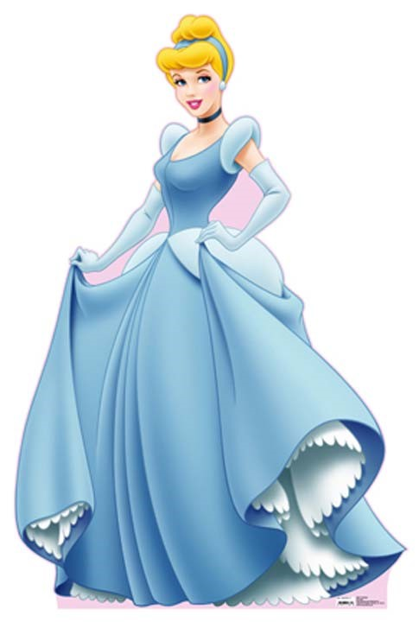
Cinderella Shop
Date of Sale:

Every Saturday during the
month of April

Time of Sale:

9:30
AM-12:30 PM
A
l
l

D
r
e
s
s
e
s

$
2
5
.
0
0

B
e
n
e
f
i
t
s

R
.
E
.
A
.
C
.
H
.

The Zion United Church of Christ is sponsoring its annual Cinderella Shop event. Each Saturday during the month of April, the Cinderella Shop will be open to sell gently used, clean prom gowns. All gowns will be sold for $25.00 (cash or check made payable to R.E.A.C.H.).
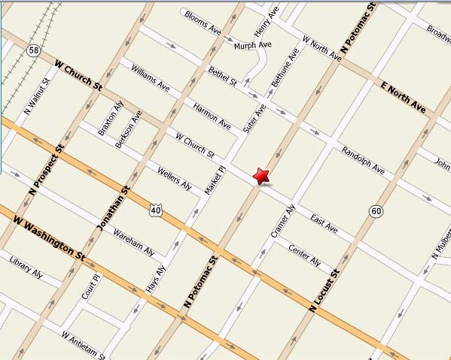

Zion United Church of Christ
210 N. Potomac Street
Hagerstown, MD 21740
Phone: 301-739-7244
Fax: 301-739-3671
E-mail: zionrucc@myactv.net
Web Site: https://zionreformed.church
Questions: 240.313.0582
Interested in Donating?
Gently used, clean prom gowns may be brought to the church office Monday through Friday between 9:00 AM and 12:00 PM.

