

SATURDAY MATINEE
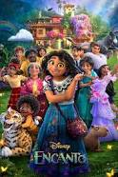
JOIN US TO WATCH
DISNEY’S ENCANTO
JULY 16, 2022 | 3:00PM | ZION RUCC  201 N Potomac St  Hagerstown, MD 21740  301-7397244
A fun afternoon of family entertainment with Disney's award-winning movie Encanto in our Chapel.
Movie snacks will be available.

