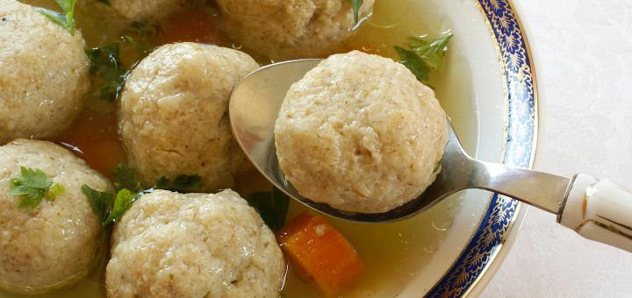 |  | 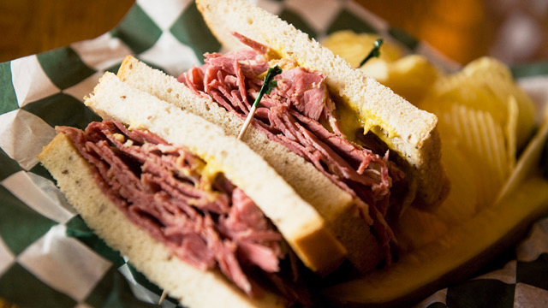
March Mishagas (Madness)
A Jewish Food Festival To Go!
Pick – Up Sunday, March 6, 2022 -- Order Deadline: March 1st
EZ Order & pay online: www.bnaiabraham.net/foodfestival
Name: ___________________________________________________
Phone #: _________________________________________________
Email: ___________________________________________________
Address: _________________________________________________
_________________________________________________
FABULOUS LEAN BRISKET DINNER -- $20.00 Qty.___ @$20ea. $________
Includes gravy, Israeli couscous, deli pickle, cole slaw, and sweet lokshen
kugel (it’s the Jewish version of Bread Pudding, made with noodles).
NOSH Box -- $16.00
Includes stacked sandwich on rye, deli pickle, cole slaw, kugel
Corned Beef Qty.___ @$16ea. $_________
Pastrami Qty.___ @$16ea. $_________
Turkey Qty.___ @$16ea. $_________
MATZAH BALL SOUP -- $8.00/Quart Qty.___ @$ 8ea. $________
BUBBIE’S VEGETARIAN BEAN SOUP -- $8.00/Quart Qty.___ @$ 8ea. $________
ORDER TOTAL $________
PICKUP TIME (choose one) Between 11:30-1:30 or Between 3:30-5:30

Orders will be picked up at 53 E. Baltimore Street.
Drive through parking lot to the pick up station.
If you send in a hardcopy order, payment may be made online:
www.bnaiabraham.net/donations/
Please specify your order when making a PayPal donation in the comments, such as ‘1 corned beef nosh box’, etc.
------------------------------------------------------Office Use Only -----------------------------------------------
Order Taker: ____________________ Cash Check # ______________

