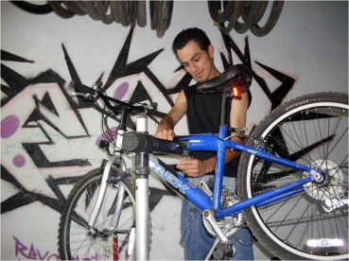
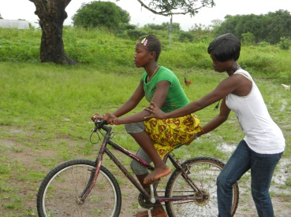
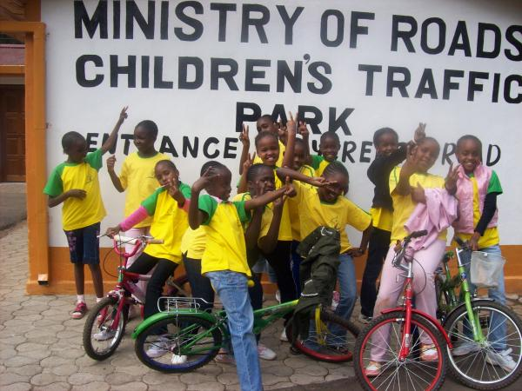
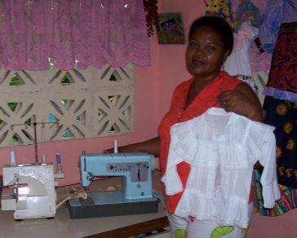

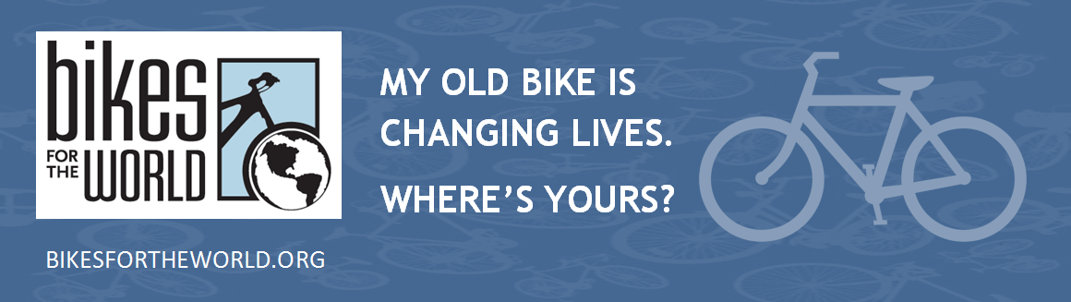
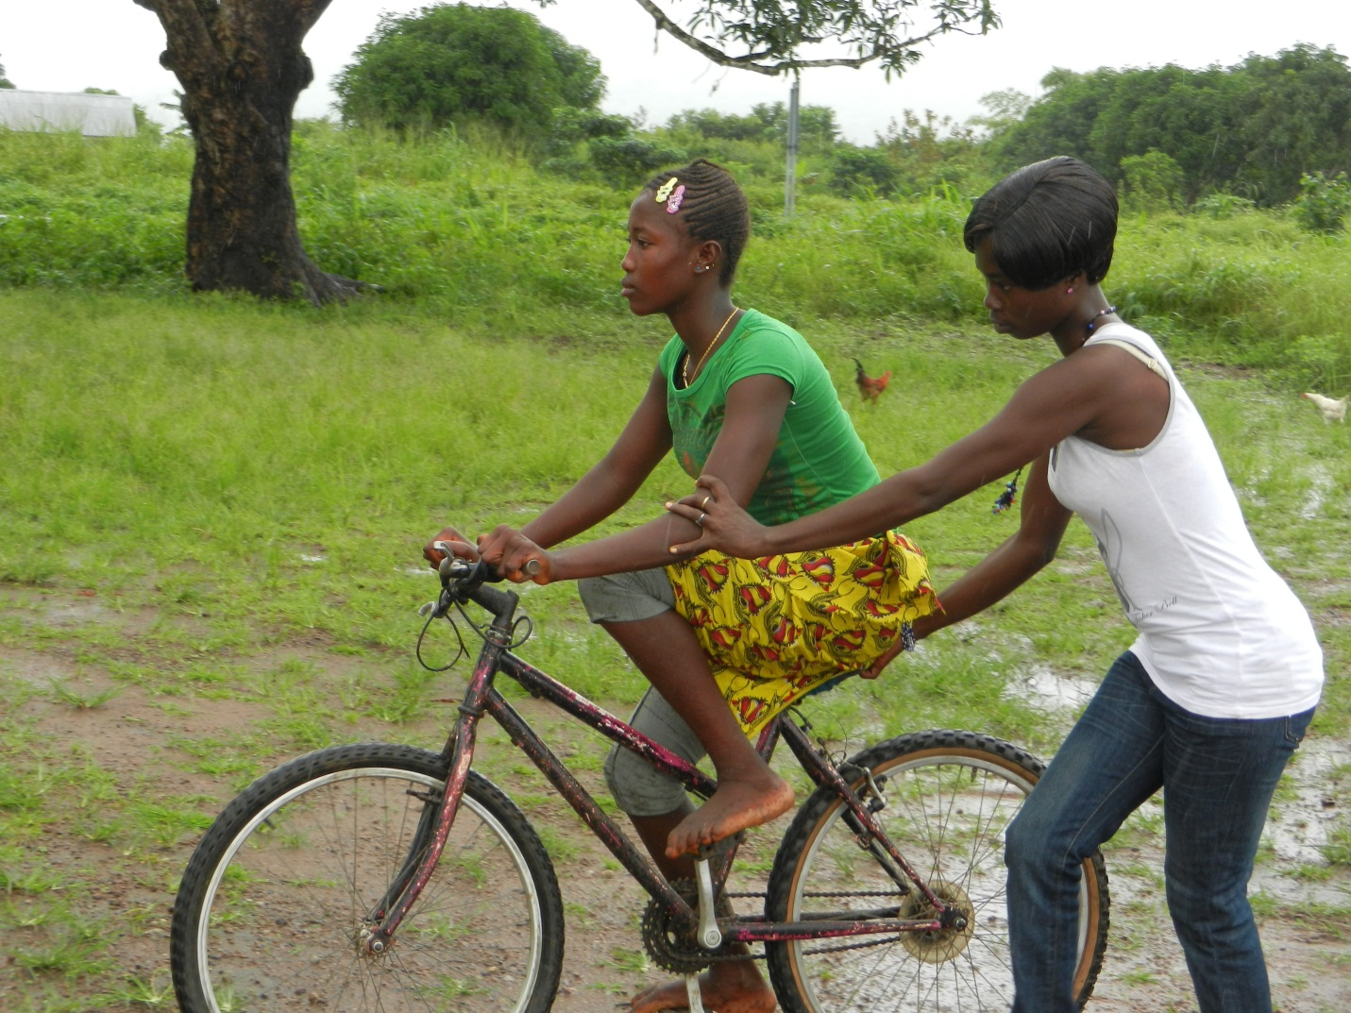
Re-Cycle
Re-Use
UPCOMING
BICYCLE COLLECTION
Saturday June 26 9am—12pm

Otterbein United Methodist Church
108 E Franklin St
Hagerstown MD 21740

Contact info:
Cindy or Mike
Cindy.brown@otterumc.org or 301.739.9386
mike1@msjohnston.com or 301.331.9153

PUT YOUR OLD BIKE or SEWING MACHINE TO GOOD USE
Help someone get to work, school and health services.
DONATE IT HERE:
A $10 per bike donation is suggested to defray a share of the
cost of shipping to overseas charity partners, which recondition
the bicycles and distribute them to people who need them
to get to work, school, and health services.
Bikes for the World is a a 501(c)(3) non-profit charity. A receipt
will be provided for all material and cash donations. Checks accepted.
office@bikesfortheworld.org 703.740.7856

